Chapter 5, Problem 93

A voltage-to-current converter is shown in Fig. 5.110, which means that i_{L} = Av_{i} if R₁R₂ = R₃R₄. Find the constant term A.

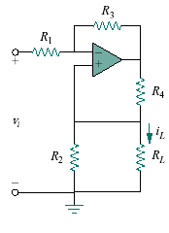
Figure 5.110
For Prob. 5.93.

